BOOKENDS HOSPITALITY PVT. LTD.
Internal Operations — Regulatory Readiness Series
FSSAI Internal Food Safety Audit — Checklist Report
Capiche Vesu · 51 lines assessed · 19 ★ critical · 9 lines removed as not applicable
Outlet / Brand | Capiche | Audit Date | 02/09/2026
Location | Vesu, Surat. | Time Start – End | 10:30AM to 01:30PM
Business Category | Restaurant | Audit Type | Surprise
Auditor | Vishal Patel | Report Prepared By | Nikil Malaviya
Marking: Compliant — 2 marks Minor — 1 mark Major — 0 NA — not applicable, excluded ★ critical — marks count double
One rating per line. Every Minor or Major carries a remark in the ‘Remark / Photo’ column, with the photograph in the same cell.
Line | Area | Requirement / How to verify | ★ | Rating | Remark / Photo
A. Service Area
1  ref 1 | Menu information  Restaurant | Veg / non-veg mark and allergen information on the menu (where applicable).  How to verify: Pick up a menu card — every non-veg dish should carry a red mark and every veg dish a green one. Then choose three dishes containing peanut, sesame, milk or wheat and ask how the guest is told. | 0 | Major | 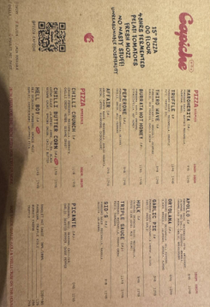
2  ref 2 | Table items  Restaurant | Table condiments and sachets within their expiry date; containers clean.  How to verify: Look at the bottom of the sauce bottles on three tables, and inside the sachet holder. | 2 | Compliant
3  ref 3 | Display / buffet  Restaurant | Counters and display units clean; displayed food covered and held at the correct temperature.  How to verify: Probe the buffet while service is running and ask how long that tray has been out. | 2 | Compliant
4  ref 4 | Complaints  Both | A guest complaint system in place; investigation and closure recorded in the complaint register.  How to verify: A register with zero complaints all year is not a good sign — it is an unused register. | 1 | Minor | The pizza dough seemed a little thick.
5  ref 5 | Crockery and cutlery  Restaurant | Crockery, cutlery and glassware clean, unchipped and stored covered.  How to verify: Hold ten items up to the light. Watch how the runner picks up glasses — fingers inside the rim is a finding. | 0 | Major | 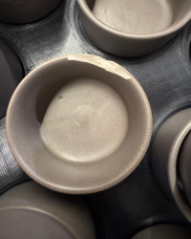
6  ref 6 | Drinking water  Restaurant | Drinking water potable / filtered; dispenser and jug clean.  How to verify: Trace where the guest water comes from. Open the dispenser and look at the drip tray. | ★  4 | Compliant
7  ref 7 | Ice  Restaurant | Ice for drinks made from potable water, kept covered, scoop stored outside the bin, no hand contact.  How to verify: Look inside the ice bin. A glass used as a scoop, or a scoop buried in the ice, is an immediate finding. | ★  4 | Compliant
8  ref 8 | Guest washroom  Restaurant | Handwash or sanitiser available for guests and staff; restrooms clean and stocked; doors must not open directly into the food area.  How to verify: Use it yourself. Check which way the door opens and whether the bin is covered. | 2 | Compliant
9  ref 9 | Service staff hygiene  Restaurant | Service staff in clean uniform, hands clean, hair tied, no jewellery; dishes carried without touching the food surface.  How to verify: Stand at the pass and watch five dishes go out. This one is to be watched, not asked. | 2 | Compliant
10  ref 10 | Pest — dining  Restaurant | Pest barrier working at the entrance — air curtain / insect-o-cutor; no sign of pests in the dining area.  How to verify: Check the insect killer tray and the window edges. Look under the fixed seating too. | 2 | Compliant
11  ref 12 | Illness  Both | No unwell staff on duty; cuts and wounds covered with a waterproof dressing.  How to verify: Look at the staff's hands — if there is a plaster, is it waterproof and coloured so it is visible? Ask the newest member what they do if they have diarrhoea or fever; the answer tells you whether the rule is real or only on paper. | ★  4 | Compliant
B. Kitchen Area
12  ref 13 | Layout  Both | Enough room to work, clean and maintain, and a design that keeps dust, waste and pests out.  How to verify: Find the spot where two people carrying hot pans have to pass each other, and the corners a mop cannot reach. | 0 | Major | 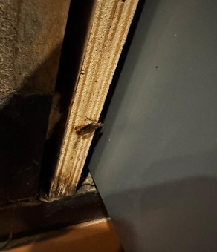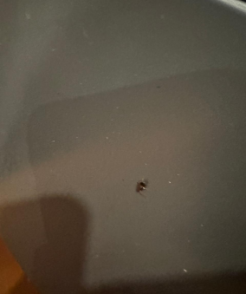
13  ref 14 | Construction  Both | Internal construction and fittings made of non-toxic, non-absorbent, smooth and cleanable material.  How to verify: Run your hand along the prep counter and shelves. Wood, rust and peeling laminate are all findings. | 2 | Compliant
14  ref 15 | Flooring  Both | Floor non-slip, sloped towards the drain, coving at the wall-floor joint; no cracks or broken tiles.  How to verify: Walk the whole floor including under the racks. Pour a mug of water at the lowest point and see where it goes. | 1 | Minor | 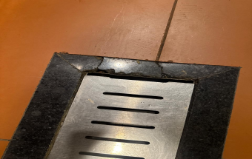
15  ref 16 | Segregation  Both | Raw and cooked / ready-to-eat areas separated; veg and non-veg separated in both prep and storage.  How to verify: Colour-coded boards and knives should be in use, not lying in a drawer. Check the chiller shelves too. | ★  0 | Major
16  ref 17 | Ventilation  Both | Adequate ventilation and an exhaust over the cooking line; no condensation or grease dripping onto food.  How to verify: Tissue test at the edge of the hood. Check the duct joints and the ceiling above the range. | 0 | Major | 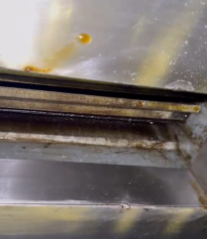
17  ref 18 | Drainage  Both | Drainage adequate, trapped and covered, flowing away from the food area; no cross-connection with potable water.  How to verify: Look during the peak washing period, not at 4 pm. Smell at floor level for dry traps. | 2 | Compliant
18  ref 19 | Handwashing  Both | A dedicated handwash basin at the entrance to the food area, with soap, running water and a means of drying hands.  How to verify: Turn the tap on. A sink where vegetables are washed is not a handwash sink. | 2 | Compliant
19  ref 20 | Temperature control  Both | Enough chilling, freezing and hot-holding capacity for the volume handled, each with a working thermometer.  How to verify: Count the units against peak volume. An uncalibrated thermometer proves nothing. | ★  4 | Compliant
20  ref 21 | Equipment  Both | Equipment of food-grade material, designed to be cleanable, in sound condition; measuring devices calibrated.  How to verify: Look under the prep tables and behind the equipment. Ask for the calibration record for the probe and the scale. | 1 | Minor | Weighing scale calibration.
21  ref 22 | Receiving  Both | Incoming goods checked and recorded — condition, temperature, date, vehicle cleanliness; rejections recorded too.  How to verify: A register with no rejection ever recorded usually means nobody is checking. | 2 | Compliant
22  ref 23 | Unsafe food  Both | Nothing expired, undated, unlabelled or visibly unsafe anywhere on the premises.  How to verify: Open the back row of every shelf and the bottom of every freezer basket. That is where it hides. | ★  0 | Major | 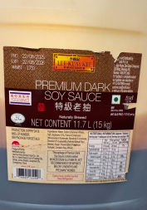  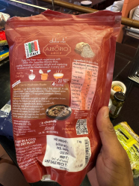  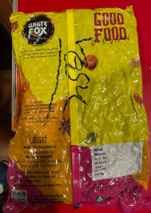  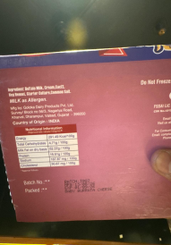  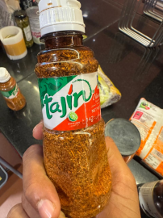
23  ref 24 | Stock rotation  Both | FIFO followed; every stored item marked with the receipt or prep date and a use-by date.  How to verify: Pick five containers at random. An unlabelled container is an undated container. | 0 | Major | 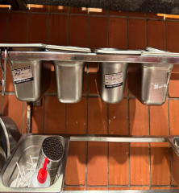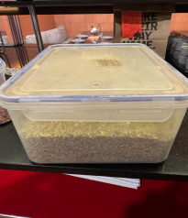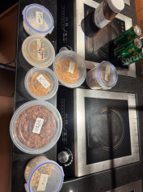
24  ref 25 | Storage  Both | Storage at least 15 cm off the floor and away from the wall; nothing kept under toilets, passages or sinks.  How to verify: Look under the lowest rack and behind the doors. | 2 | Compliant
25  ref 26 | Storage  Both | Raw and cooked separated; cooked and ready-to-eat stored above raw; everything in covered containers.  How to verify: Open the chiller and look at the shelf order. Raw chicken above cooked rice is an immediate finding. | ★  0 | Major | 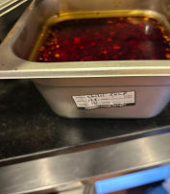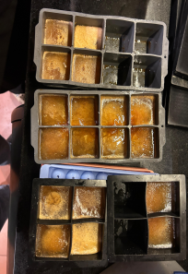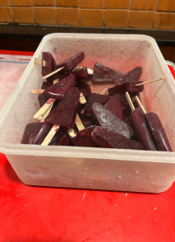
26  ref 27 | Cold chain  Both | Chillers at 5 °C or below, freezers at −18 °C or below; measured and logged at a set frequency, with action taken on exceptions.  How to verify: Probe it yourself and compare with today's log. A gap between probe and log is two findings. | ★  0 | Major | 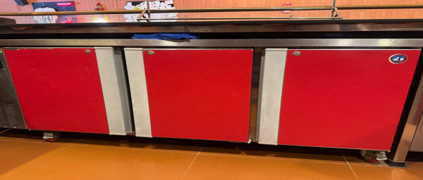
27  ref 28 | Cooking  Both | Core cooking temperature 75 °C or above; hot holding 60 °C or above; cold display 5 °C or below.  How to verify: Probe during service, not a sample made for you. Measure the centre of the thickest piece. | ★  4 | Compliant
28  ref 29 | Thawing  Both | Thawing only under refrigeration, under running potable water or in a microwave — never in the open.  How to verify: Check the sink and back counter during morning prep. This is a prep-time check, not a paper one. | 2 | Compliant
29  ref 30 | Reheating  Both | Reheat to 75 °C or above, once only; a written policy for leftovers that staff can state.  How to verify: Ask the chef what happens to leftover gravy at closing. The answer should match the written policy. | 2 | Compliant
30  ref 32 | Additives  Both | Only approved additives and colours, within limits; declaration and supplier COA on file.  How to verify: Look for unlabelled colour sachets in the spice store. This is a criminal-liability item. | ★  4 | Compliant
31  ref 33 | Frying oil  Both | Frying oil TPC within limit, measured with a tester and recorded; used oil disposed of through a registered agency.  How to verify: Ask for the oil tester and the last readings. Check the collection receipts for used oil. | 2 | Compliant
32  ref 34 | Chemicals  Both | Cleaning chemicals and pesticides kept away from food, clearly labelled, in a lockable place.  How to verify: A sanitiser bottle on the prep shelf is not convenience, it is an adulteration risk. | ★  4 | Compliant
33  ref 35 | Packaging  Both | Food-contact packaging food grade, supplier certificate on file; not reused for other purposes.  How to verify: Check what the oil tins and paint buckets at the back are being used for. | 2 | Compliant
34  ref 39 | Sanitation  Both | Food-contact surfaces cleaned and sanitised between raw and cooked work; approved sanitiser at the correct strength.  How to verify: Watch the sanitiser being made up. Check the dilution against the label, and whether test strips exist. | ★  4 | Compliant
35  ref 40 | PPE  Both | Aprons, gloves, headgear and masks issued, in good condition, and changed at the right times.  How to verify: Gloves not changed all morning are worse than no gloves at all. | 2 | Compliant
C. Whole Premises and Documentation
36  ref 41 | FSSAI licence  Both | FSSAI licence valid, of the correct category, carrying this unit's address, and displayed where it can be seen.  How to verify: Read the licence yourself: validity date, category, address. A head-office licence does not cover this kitchen. | ★  4 | Compliant
37  ref 43 | FSSAI licence  Both | FSSAI licence number printed on the menu, the bill and the label of every packed item.  How to verify: Pick up one bill and one menu card. In a CPK, take one packed item off the dispatch rack. | 0 | Major | 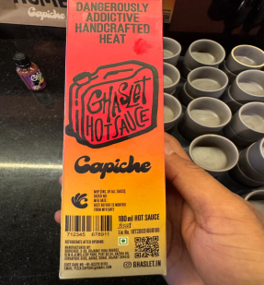
38  ref 44 | Display  Both | Food Safety Display Board, hygiene rating certificate (if any), no-smoking and handwashing notices put up.  How to verify: Walk the guest area and the kitchen entrance. A board behind a rack does not count as 'put up'. | 0 | Major | Food Safety Display Board not put up; no-smoking notice not put up.
39  ref 45 | Construction  Both | No plaster or paint flaking from walls, ceilings or doors; no condensation; no particles falling.  How to verify: Torch the ceiling corners and behind the dishwash. Look directly above open food. | 2 | Compliant
40  ref 46 | Lighting  Both | Enough light to work by; lights above open food shatterproof or covered.  How to verify: Look up over every open-food surface. A bare tube over the prep table is a finding. | 2 | Compliant
41  ref 47 | Water  Both | Adequate supply of potable water; water in contact with food potable; lab report within the required period.  How to verify: Check the report date, the parameters tested, and that the sample point is this unit. | ★  0 | Major | No record.  No rating was circled — read off the remark as Major.
42  ref 51 | Cleaning system  Both | Cleaning schedule up to date and signed; dispatch log with temperatures (CK outlets).  How to verify: Take one line off the schedule and touch that surface yourself — signed but greasy is a finding, not a pass. For CPK/CK, check whether last week's dispatch slips carry temperatures. | 0 | Major | 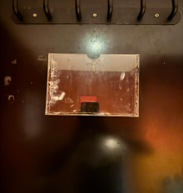
43  ref 52 | Pest control  Both | Pest control by a licensed agency at a set frequency; bait map and service records on file; no signs of pests.  How to verify: Torch under the equipment and along the wall-floor joint first, then look at the records. | ★  0 | Major | No record.
44  ref 53 | Medical fitness  Both | An annual medical fitness certificate for every food handler.  How to verify: Count the certificates against today's staff list, not last year's. Check the dates. | ★  4 | Compliant
45  ref 54 | Appearance  Both | Clean uniform, head covered, no jewellery, nails short and unpainted, no watches in the food area.  How to verify: Not a team lined up for you — look at hands and hairlines during service. | 2 | Compliant
46  ref 55 | Handwashing  Both | Hands washed at the designated point and at every change of task; cooked or ready-to-eat food never touched with bare hands.  How to verify: Stand quietly at the pass for five minutes. This one is to be watched, not asked. | ★  4 | Compliant
47  ref 56 | Conduct  Both | No smoking, spitting, eating or chewing in the food area; notices displayed and followed.  How to verify: Not the main kitchen — check the back staircase and the store room. | 1 | Minor | The notices are not put up.
48  ref 57 | FoSTaC  Both | One FoSTaC-trained Food Safety Supervisor for every 25 food handlers, with a valid certificate.  How to verify: Count the handlers, count the certificates, check the expiry. This is a licence condition and it blocks renewal. | ★  0 | Major | No certificate.
49  ref 58 | Training  Both | Induction and refresher food safety training for all handlers; records with date, topic and signature.  How to verify: Take one name off the training list and ask that person what they were taught. | 1 | Minor | No record.
50  ref 59 | Records  Both | Records available and kept for one year or the shelf life, whichever is longer — temperature, cleaning, pest, water, oil, medical, training, supplier.  How to verify: Ask for one specific date three months ago and see how long it takes to produce it. | ★  0 | Major | No pest control record, no water report, no training record.
51  ref 60 | Regulator follow-up  Both | Findings from the last FSO inspection or improvement notice closed within the deadline, with evidence.  How to verify: Ask for the last inspection report. Even 'they have never come' has to be evidenced by the file. | 0 | Major | Expired stock; no pest control record; no water report; no training record.
Score and Grade
Section | Available marks | Obtained marks | %
A. Service Area | 28 | 23 | 82.1%
B. Kitchen Area | 66 | 42 | 63.6%
C. Whole Premises and Documentation | 46 | 20 | 43.5%
Total | 140 | 85 | 60.7%

Conclusion
• Overall standing — 85/140 (60.7%), Needs Improvement. By section: A Service Area 82.1% (Satisfactory), B Kitchen Area 63.6% (Needs Improvement), C Whole Premises and Documentation 43.5% (Non-Compliance).
• Close the ★ critical lines first — 8 ★ critical lines are rated Major (lines 15, 22, 25, 26, 41, 43, 48, 50) and they carry 32 marks between them. Closing those 8 alone takes the score to 117/140 (83.6%), inside the Satisfactory band. 80% needs 112 marks; the unit has 85, so it is 27 short.
• Of the 17 Major lines, 10 are paperwork and 7 are physical — paperwork: lines 1, 23, 37, 38, 41, 42, 43, 48, 50, 51 (Menu information · Stock rotation · FSSAI licence · Display · Water · Cleaning system · Pest control · FoSTaC · Records · Regulator follow-up). The work is being done but no record exists, and that set can be closed in a week or two. Physical: lines 5, 12, 15, 16, 22, 25, 26 (Crockery and cutlery · Layout · Segregation · Ventilation · Unsafe food · Storage · Cold chain) — real work on site, of which the expired stock on line 22 (★) is the most urgent.

